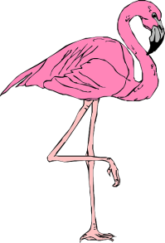

Special Occasion?
Give a Flocking!!
Do you know someone who is having a birthday, new baby, anniversary or other special celebration? Why not celebrate in style with a whole flock of pink flamingos?

Hayfield Secondary School's 2018 All-Night Grad Party (ANGP) Committee will "flock" your friend's yard under the cover of darkness. Your special person will awaken to a front yard filled with a dozen brightly colored birds, along with a card announcing who sent the flock. The birds will be picked up the following evening.

Each flocking costs $25 and includes 12 flamingos and a personalized card from the sender. For an additional $10, we can dress one flamingo for the occasion. Please note that we can flock only yards within the Hayfield Secondary School pyramid or nearby neighborhoods (subject to ANGP approval). Please allow at least one week's notice. There will be an additional $20 rush charge for a flocking with less than one week's notice, if the flocking can be arranged.

Please send order form and payment to: Diane Kutz, 5625 Glenwood Mews Drive, Alexandria, VA 22315; phone: 703-201-3679; email: ANGP2018@gmail.com. Checks should be made payable to "Hayfield SS PTSA/ANGP".
Thanks for having fun with us and sending a flock!
The All Night Grad Party Committee Class of 2018
The All-Night Grad Party is a drug- and alcohol-free all-night celebration that provides a
safe haven for graduates to celebrate this spectacular milestone in their lives. All proceeds directly offset the cost of
this event, which is typically attended by a majority of the graduating class.

Person/Family Being Flocked:
Name:
Address:
Neighborhood: Phone:
Delivery Date: Occasion:
(delivery date should be the night BEFORE the occasion – one week’s notice required)
Flock Purchased by:
Name: Address:
Email Address: Phone:
Message on card:
Card signed by:
Payment: Flock ($25) __________ Dressed ($10) __________ Rush*($20) __________ Total ______________

